Name: Abdul Rehman

ID: 149019176

Lab on Schema objects

Solve the following:

1. Create the EMPLOYEES2 table based on the structure of the EMPLOYEES table. Include only the EMPLOYEE_ID, FIRST_NAME, LAST_NAME, SALARY, and DEPARTMENT_ID columns. Name the columns in your new table ID, FIRST_NAME, LAST_NAME, SALARY, and DEPT_ID, respectively.

Statement:

CREATE TABLE employees2

AS (SELECT EMPLOYEE_ID as "ID", FIRST_NAME , LAST_NAME, SALARY, DEPARTMENT_ID "DEPT_ID"

FROM employees);

Output:

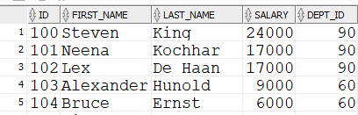

1. Use the employees2 table that you created in the previous lab on DDL and Schema Objects. Alter the EMPLOYEES2 table status to read-only.

Statement:

ALTER TABLE employees2 READ ONLY;

Output: Not applicable

1. Try to insert the following row in the table:

34, ‘Grant’, ‘Marcie’, 5678, 10

Show the result of executing the insert statement.

Statement:

INSERT INTO employees2 values (34, 'Grant', 'Marcie', 5678, 10);

Output:

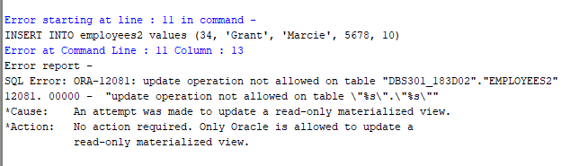

1. Revert the EMPLOYEES2 table to read/write status. Now try to insert the same row again.

Show the result.

Statement:

1-) ALTER TABLE employees2 READ WRITE;

2-) INSERT INTO employees2 values (34, 'Grant', 'Marcie', 5678, 10);

Output:



1. Drop the EMPLOYEES2 table.

Statement:

drop table employees2;

Output:



1. The staff in the HR department wants to hide some of the data in the EMPLOYEES table. They want a view called EMPLOYEES_VU based on the employee numbers, employee last names, and department numbers from the EMPLOYEES table. They want the heading for the employee name to be EMPLOYEE.

Statement:

CREATE VIEW EMPLOYEES_VU

AS select employee_id, last_name "EMPLOYEE", department_id

from employees;

1. Confirm that the view works. Display the contents of the EMPLOYEES_VU view.

Statement:

Select * from employees_vu;

Output:

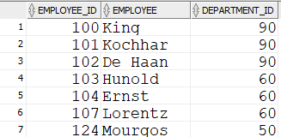

Rows: 20

1. Using your EMPLOYEES_VU view, write a query for the HR department to display all employee names and department numbers.

Statement:

select employee, department_id

from employees_vu;

Output:

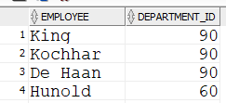

Rows:20

1. Department 50 needs access to its employee data. Create a view named DEPT 50 that contains the employee numbers, employee last names, and department numbers for all employees in department 50. They have requested that you label the view columns EMPNO, EMPLOYEE, and DEPTNO. For security purposes, do not allow an employee to be reassigned to another department through the view.

Statement:

create view DEPT50 AS

select employee_id "EMPNO", last_name "EMPLOYEE", department_id "DEPTNO"

from employees

where department_id = 50

WITH CHECK OPTION CONSTRAINT dept50_ck;

1. Display the structure and contents of the DEPT50 view.

Select * from dept50

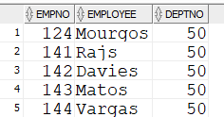

1. Test your view. Attempt to reassign Matos to department 80.

Output:

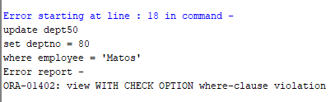

1. Create the DEPT table based on departments table. You need a sequence that can be used with the primary key column of the DEPT table. The sequence should start at 200 and have a maximum value of 1000. Have your sequence increment by 10. Name the sequence DEPT_ID_SEQ.

Statement:

CREATE SEQUENCE DEPT_ID_SEQ

INCREMENT BY 10

START WITH 200

MAXVALUE 1000;

create table DEPT as

(select * from departments);

Output:





1. To test your sequence, insert two rows in the DEPT table. Be sure to use the sequence that you created for the ID column. Add two departments: Education and Administration. Confirm your additions.

Statement:

INSERT INTO DEPT

VALUES (DEPT_ID_SEQ.NEXTVAL,

'Education',900, 9000);

INSERT INTO DEPT

VALUES (DEPT_ID_SEQ.NEXTVAL,

'Administration',900, 9000);

select * from dept

order by department_id desc;

Output:

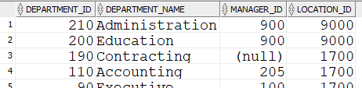

1. Create a nonunique index on the NAME column in the DEPT table.

CREATE INDEX dept_name_index

ON dept(department_name);

1. Create a synonym for your EMPLOYEES table. Call it EMP.

CREATE SYNONYM EMP

FOR EMPLOYEES;